Course Name: | Digital Signal and Image Processing | Semester: | VI
Date of Performance: | 11 / 02 / 2026 | DIV/ Batch No: | A1
Student Name: | Aaryan Sharma | Roll No: | 16010123012

Title: Write a program to Compute linear and circular convolution of two discrete time signal sequences using Matlab.

Objective: To familiarize the beginner to MATLAB by introducing the basic features and commands of the program.

Expected Outcome of Experiment:
CO | Outcome
CO3 | To understand the concept of convolution and perform different convolution operations on the given input signals.

Books/ Journals/ Websites referred:
- http://www.mathworks.com/support/
- www.math.mtu.edu/~msgocken/intro/intro.html
- www.mccormick.northwestern.edu/docs/efirst/matlab.pdf
- A.Nagoor Kani “Digital Signal Processing”, 2nd Edition, TMH Education.

Pre Lab/ Prior Concepts:
Convolution
Discrete time convolution is a method of finding response of linear time invariant system. It is based on the concepts of linearity and time invariance and assumes that the system information
is known in terms of its impulse response h[n].
Convolution is defined as
∞
Y[n] = Σ h[k]x [n-k] =h[n]*x[n] k=-∞
Convolution consists of folding, shifting, Multiplication and summation operations.

Circular Convolution
Circular convolution between two length N sequences can be carried out as shown by the expression below:
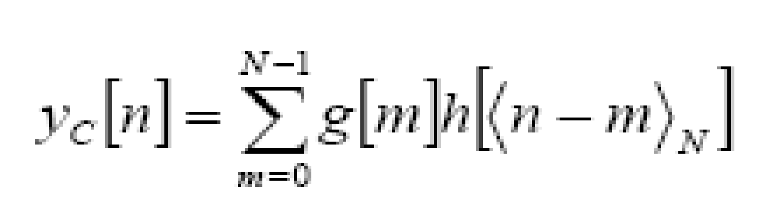
Since the above operation involves two length-N sequences it is referred to as the N-point circular convolution and denoted by:
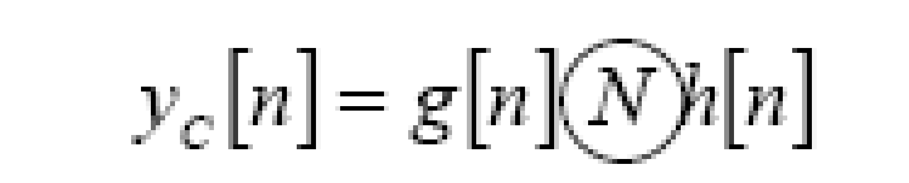
As in linear convolution circular convolution is commutative.
i.e.
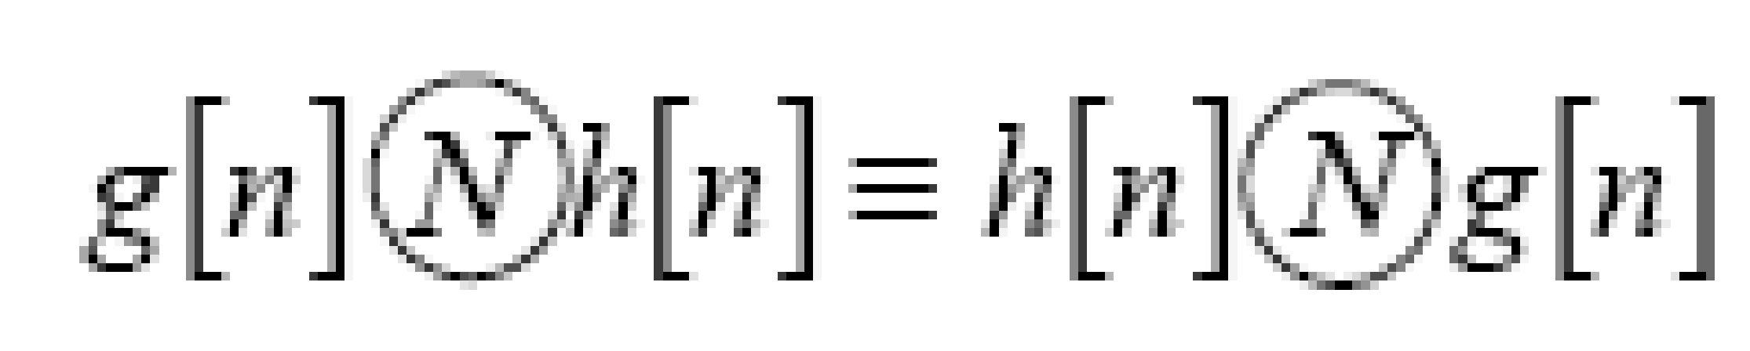
Example Of Linear Convolution:

Example Of Circular Convolution:

Implementation details along with screenshots:

Conclusion:

Date: 11 / 02 / 2026 Signature of faculty in-charge
Post Lab Descriptive Questions
  - Explain the role of convolution in signal processing.
  - Explain the difference between linear and circular convolution?
  - Explain with the help of an example the steps required to transform linear convolution with circular convolution and vice-versa.

